Module 4 - Test driven development and Logging framework
Mockito exercises
Exercise 1: Mocking and Stubbing
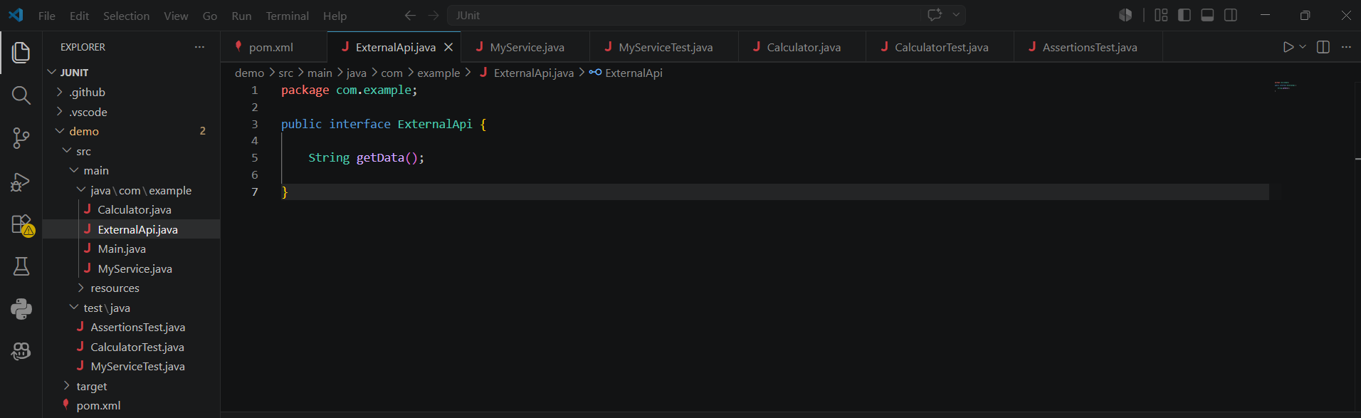

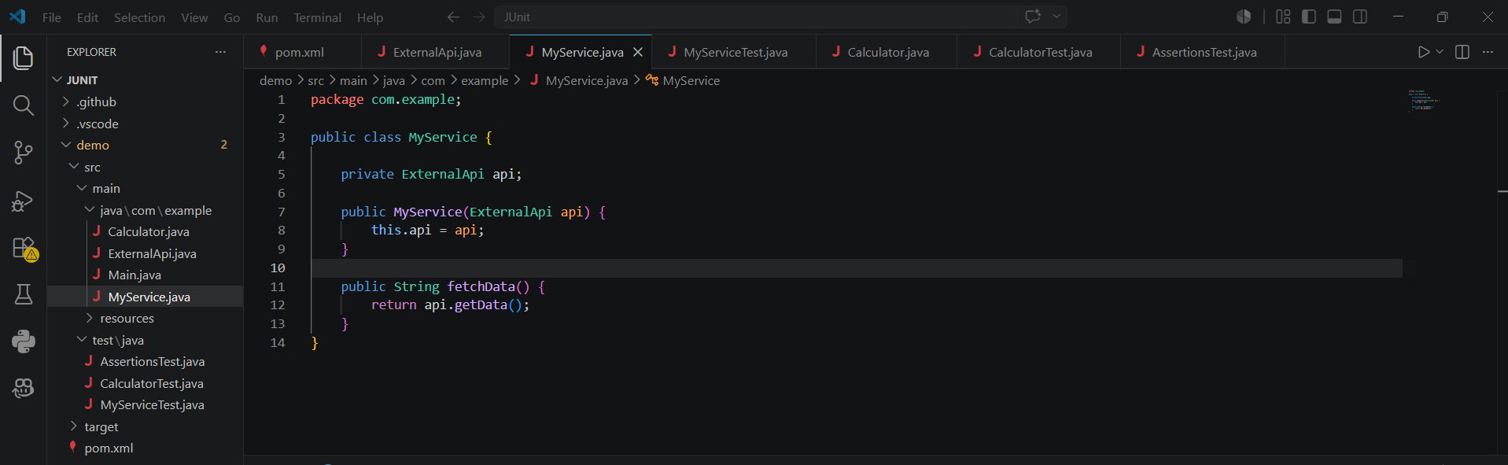

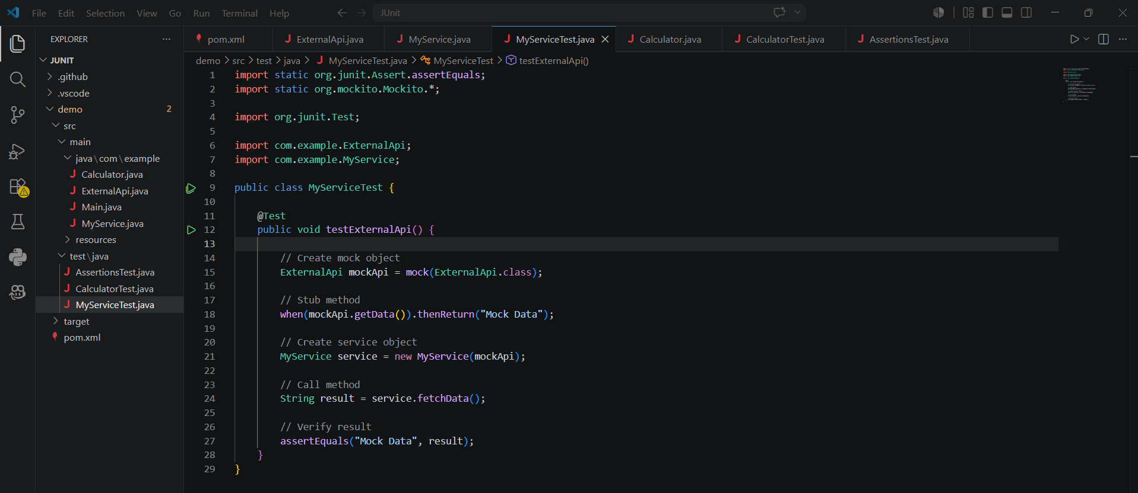

Output
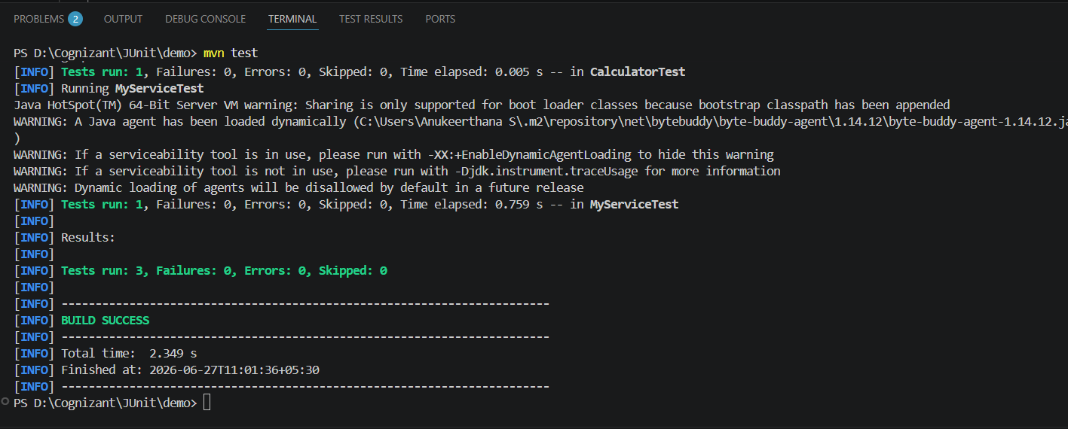

Exercise 2: Verifying Interactions
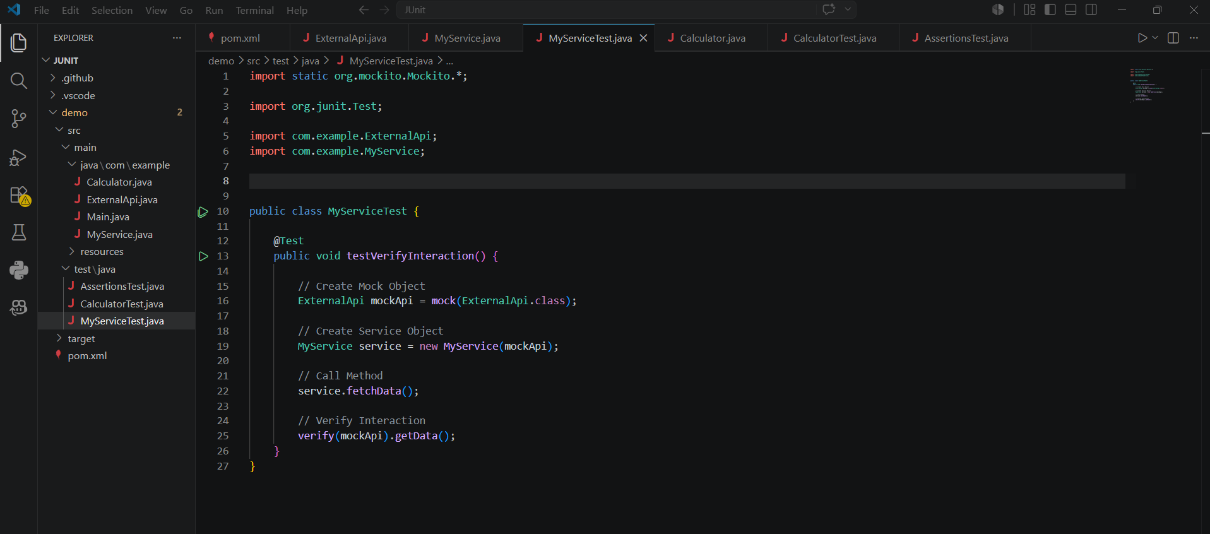

Output:
